**Assignment 2 – Report**

Group members: Caiwei He(caiweih2), Chengrui Zhu, Kelong Wu(加上netid啊同志们)

**Part 1**

* 1. Smaller input

The variables are cells in the puzzle, the domains are the colors in the puzzle, and the constraints are that:

1. For each non-source cell, there has to be only two neighbors of it having the same color as it has.
2. For each source cell, there has to be only one neighbor of it having the same color as it has.

In the dumb solution, we just take each variable and assign random colors from the domain and do the constraints check when all the cells are assigned colors. This solution is so dumb that it couldn’t give solutions to the given three puzzles in a decent amount of time.

In the smart solution, we use “most constrained variable” strategy and forward checking. We always assign the variable with the least unassigned neighbors first in every iteration. And when a cell is assigned a color, we check if the color of this cell is legal by checking if the neighbors of it have or will have legal values to help it satisfy the constraints, and also, we check if the assigned neighbors of this cell are or will be legal given the color may affect the legality of the neighbors.

And the results are shown below:

|  |  |  |  |
| --- | --- | --- | --- |
| Assignments/seconds | 7*7 | 8*8 | 9*9 |
| Dumb | - | - | - |
| Smart | 99/0.0309 | 69/0.315 | 1488/0.698 |

Result:

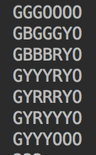 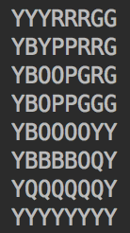 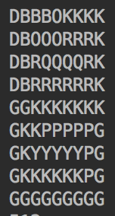

7*7 8*8 9*9

* 1. Bigger input

In the smarter solution, based on the smart solution, we add “least constraining value” and arc consistency. When assigning colors to a cell, the colors that the cell’s neighbors have will be assigned first, because that will rule out the fewest colors in the remaining unassigned cells. And when a cell is assigned a color, we check if there remains legal color for the unassigned neighbors of the cell. For example, if an unassigned neighbor has four neighbors having four different colors given the cell is assigned red, the unassigned neighbor has no legal value, so we stop searching for this cell to be assigned red, as fig.1 shows.



Fig. 1 An example of illegal situation for the middle cell

And the results are shown below:

|  |  |  |
| --- | --- | --- |
| Assignments/Time(s) | 10*10(1) | 10*10(2) |
| Smart | 12677/7.690 | 9078/5.234 |
| Smarter | 9682/5.235 | 7822/4.622 |

Result:

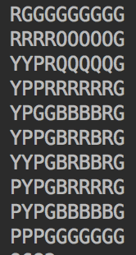 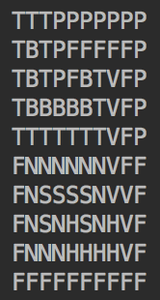

10*10(1) 10*10(2)

* 1. Extra

We keep the smart and smarter solutions for extra credit, and the results are shown below:

|  |  |  |  |
| --- | --- | --- | --- |
| Assignments/Time(s) | 12*12 | 12*14 | 14*14 |
| Smart |  | 107222/139.35 | - |
| Smarter | 26514/26.998 | 28127/35.986 | - |

Result:

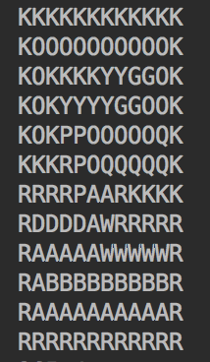 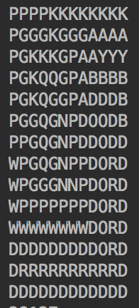

12*14 14*14